Activity | Data Type
Number of beatings from Wife | discrete
Results of rolling a dice | discrete
Weight of a person | continuous
Weight of Gold | continuous
Distance between two places | continuous
Length of a leaf | continuous
Dog's weight | continuous
Blue Color | discrete
Number of kids | discrete
Number of tickets in Indian railways | discrete
Number of times married | discrete
Gender (Male or Female) | discrete
Q1) Identify the Data type for the Following:

Q2) Identify the Data types, which were among the following
Nominal, Ordinal, Interval, Ratio.
Data | Data Type
Gender | Nominal
High School Class Ranking | Ordinal
Celsius Temperature | Interval
Weight | Ratio
Hair Color | Nominal
Socioeconomic Status | Nominal
Fahrenheit Temperature | Interval
Height | Ratio
Type of living accommodation | Nominal
Level of Agreement | Ordinal
IQ(Intelligence Scale) | Ordinal
Sales Figures | Ratio
Blood Group | Nominal
Time Of Day | Ratio
Time on a Clock with Hands | Ratio
Number of Children | Ratio
Religious Preference | Nominal
Barometer Pressure | Interval
SAT Scores | Ratio
Years of Education | Ratio

Q3) Three Coins are tossed, find the probability that two heads and one tail are obtained?
Answer-
The probability of obtaining two heads and one tail is 3/8, When tossed three coins at time.
Q4) Two Dice are rolled, find the probability that sum is
Equal to 1
Less than or equal to 4
Sum is divisible by 2 and 3

Ans-
the probability that sum is
Equal to 1=0/36
Less than or equal to 4=6/36
Sum is divisible by 2 and 3 =6/36

Q5) A bag contains 2 red, 3 green and 2 blue balls. Two balls are drawn at random. What is the probability that none of the balls drawn is blue?
Ans-
The probability that none of the balls drawn is blue is 4/9

Q6) Calculate the Expected number of candies for a randomly selected child
Below are the probabilities of count of candies for children (ignoring the nature of the child-Generalized view)
CHILD | Candies count | Probability
A | 1 | 0.015
B | 4 | 0.20
C | 3 | 0.65
D | 5 | 0.005
E | 6 | 0.01
F | 2 | 0.120
Child A – probability of having 1 candy = 0.015.
Child B – probability of having 4 candies = 0.20.

Answer-
The expected number of candies for a randomly selected child is 3.09.

Q7) Calculate Mean, Median, Mode, Variance, Standard Deviation, Range & comment about the values / draw inferences, for the given dataset
For Points,Score,Weigh>
Find Mean, Median, Mode, Variance, Standard Deviation, and Range and also Comment about the values/ Draw some inferences.
Use Q7.csv file
Answer-
 | Points | Score | Weigh
Mean | 3.596 | 3.217 | 17.848
Median | 3.695 | 3.325 | 17.71
Mode | 3.07 ,3.92 | 3.44 | 17.02,18.9
Variance | 0.285 | 0.957 | 3.193
Std | 0.534 | 0.9784 | 1.786
Range | 2.17 | 3.911 | 8.399

In this dataset –
Outliers not present in dataset.
Missing values are not present.
Column Points and Weigh Have two Mode Values.

Q8) Calculate Expected Value for the problem below
The weights (X) of patients at a clinic (in pounds), are
108, 110, 123, 134, 135, 145, 167, 187, 199
Assume one of the patients is chosen at random. What is the Expected Value of the Weight of that patient?
Answer-
the Expected Value of the Weight of that patient is 145.33 pounds.
Q9) Calculate Skewness, Kurtosis & draw inferences on the following data
Cars speed and distance
Use Q9_a.csv
Answer-
Skewness And Kurtosis
Speed=skewness= -0.117510 And Kurtosis= -0.508994
Distance=Skewness= 0.806895 And Kurtosis= 0.405053
Inferences-
1)This dataset has two columns.
2)Speed is negatively skewed but skew value is very less , it means mostly there is outliers is not present.
3)Distance is positively skewed , it means there is presence of outliers.
SP and Weight(WT)
Use Q9_b.csv
Answer-
1)SP=Skewness= 1.611450 And Kurtosis= 2.977329
2)WT= Skewness= -0.614753And Kurtosis= 0.950291
Inferences-
1)This dataset having two columns SP and WT.
2)both columns have outliers in it.
3)SP is positively skewed means it has outliers.
4)WT is negatively skewed means it has outliers.

Q10) Draw inferences about the following boxplot & histogram

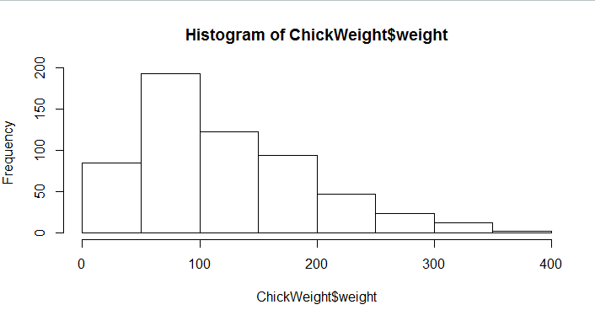
Answer-
This is histogram of chickweight variable
Histogram is positively skewed.
In this variable outliers are present
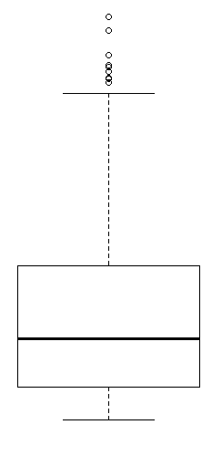
Answer-
1)boxplot always represents the actual position of outliers present in dataset or specific variable.
2)In this boxplot we clear able to see outliers are present in upper whisker length side.
3) In this boxplot we clear able to see outliers are not present in Lower whisker length side

Q11) Suppose we want to estimate the average weight of an adult male in Mexico. We draw a random sample of 2,000 men from a population of 3,000,000 men and weigh them. We find that the average person in our sample weighs 200 pounds, and the standard deviation of the sample is 30 pounds. Calculate 94%,98%,96% confidence interval?
Answer-
Confidence intervals for the average weight of adult males in Mexico at 94%, 98%, and 96% confidence levels are approximately 200±2.633pounds, 200±3.235pounds, and 200±2.862pounds, respectively.

Q12) Below are the scores obtained by a student in tests
34,36,36,38,38,39,39,40,40,41,41,41,41,42,42,45,49,56
Find mean, median, variance, standard deviation.
What can we say about the student marks?
Answer-
Mean= 41.0
Median=40.5
Variance= 25.529412
Standard Deviation= 5.052664
By Watching this values we can say that students scores at least 41 out of 100.
Q13) What is the nature of skewness when mean, median of data are equal?
Answer-
When mean and median data is almost equal that means data is normally distributed and outliers not present in it.
Q14) What is the nature of skewness when mean > median ?
Answer-
When mean > median then we can say that data is negatively skewed and has outliers .
Q15) What is the nature of skewness when median > mean?
Answer-
When mean < median then we can say that data is positively skewed and has outliers .
Q16) What does positive kurtosis value indicates for a data ?
Answer-
kurtosis represents the peak values of data.
Positive kurtosis means there is high peak values and also the presence of outliers there.
Q17) What does negative kurtosis value indicates for a data?
Answer-
kurtosis represents the peak values of data.
Negative kurtosis means there values is spread out at tail position and also the fewer peak values

Q18) Answer the below questions using the below boxplot visualization.
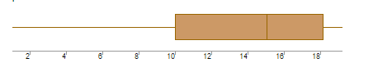
What can we say about the distribution of the data?
Answer-
As per boxplot, we can’t say it is normally distributed because median line is not at the center.
What is nature of skewness of the data?
Answer-
Negatively skewed.
What will be the IQR of the data (approximately)?
Answer-
iqr for above boxplot is 8.
Q19) Comment on the below Boxplot visualizations?
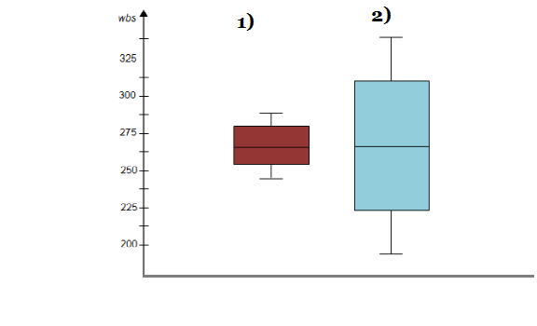
Draw an Inference from the distribution of data for Boxplot 1 with respect Boxplot 2.
Answer-
Both boxplot have same median but differently spread.
Due to median position we can say that it is normally distributed.
Range of 2nd boxplot is more than 1st .
Q 20) Calculate probability from the given dataset for the below cases

Data _set: Cars.csv
Calculate the probability of MPG of Cars for the below cases.
MPG <- Cars$MPG
Answer-
P(MPG>38) = 0.347
P(MPG<40) = 0.729
c. P (20<MPG<50) = 0.0131

Q 21) Check whether the data follows normal distribution
Check whether the MPG of Cars follows Normal Distribution
Dataset: Cars.csv
Answer- No.

Check Whether the Adipose Tissue (AT) and Waist Circumference(Waist) from wc-at data set follows Normal Distribution
Dataset: wc-at.csv
Answer-
AT-No.
Waist-No. slightly positive skewed.
Q 22) Calculate the Z scores of 90% confidence interval,94% confidence interval, 60% confidence interval
Answer-
Z scores for below values are-
1)90%=1.645 Approx.
2)94%=1.88 Approx.
3)60%=0.84 Approx.
Q 23) Calculate the t scores of 95% confidence interval, 96% confidence interval, 99% confidence interval for sample size of 25
Answer-
T Scores For Sample Size of 25 are-
1)95%=2.064
2)96%=2.171
3)99%=2.797
Q 24) A Government company claims that an average light bulb lasts 270 days. A researcher randomly selects 18 bulbs for testing. The sampled bulbs last an average of 260 days, with a standard deviation of 90 days. If the CEO's claim were true, what is the probability that 18 randomly selected bulbs would have an average life of no more than 260 days
Hint:
rcode pt(tscore,df)
df degrees of freedom
Answer-
the probability that 18randomly selected bulbs would have an average life of no more than 260 days is 0.2042994.

